Could you be a Trustee for The Bridge At Waterloo?
We are seeking new trustees to join our Board and help our charity achieve its goals and aspirations. We are particularly keen to recruit those with experience of arts, culture, venue and/or community project production and management.

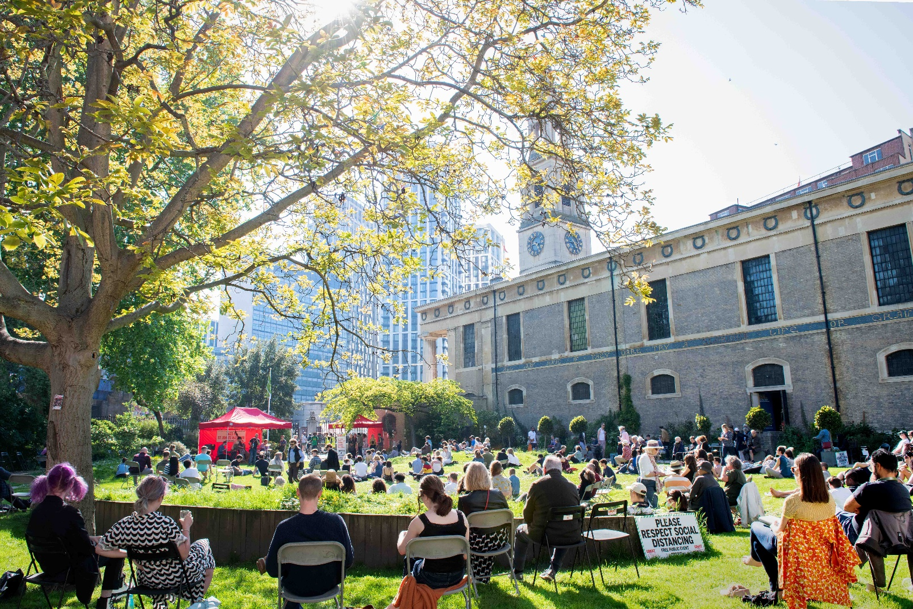

The Bridge at Waterloo is a secular charity located at and founded by St John’s Waterloo (SJW). Through our historic building, staff, volunteers and in partnership with our neighbourhood and other organisations, we promote community engagement, the arts, and horticulture to encourage social justice, communal involvement, inclusivity, and environmental responsibility.

The Bridge at Waterloo (TBAW) was founded in 2015 to work with and support marginalised communities challenging inequality on their own terms, through learning, development, empowerment, social engagement and opportunity. It aims to also develop a bridge between our participants, the cultural opportunities offered by the proximity of the South Bank and our own creative programme.

Recently, a major restoration transformed our home into an accessible performance, event and community space. Since then, we have been rededicating our energies to ensuring this historic building is being operated for the benefit of our whole community.

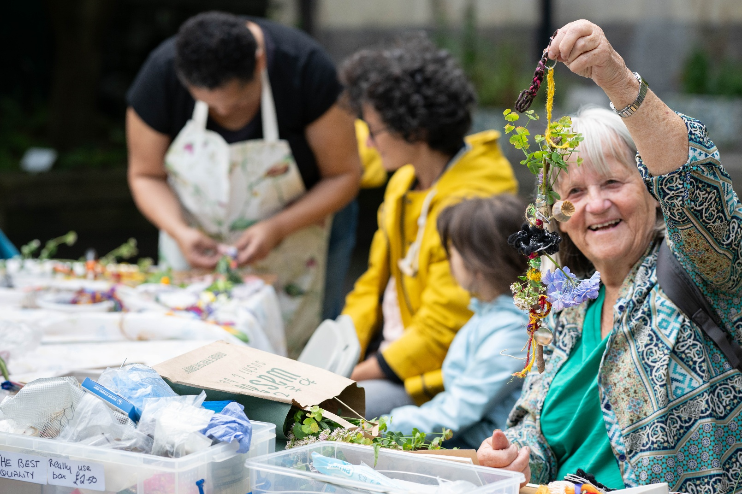

WHAT WE DO
Our pledge is to be here for everyone and through TBAW we put that into action through projects, weekly engagements and partnerships. To enable this, SJW generates revenue from hiring out the wonderful historic spaces in Waterloo and the halls at St Andrew’s, and we also raise money from grants and donations to fund practical projects. This enables us to respond to what matters right now to the communities who need us. Below are some examples of projects we have been running.

Room for You: every Tuesday, from 9:30am onwards, our The Bridge At Waterloo Room at St John’s hosts a variety of activities or simply offers a place to relax, have a chat over a hot drink and make use of our free Wi-Fi. Over the course of the day, participants can join one of our clubs all supported by our Outreach and Engagement Officer, support workers and volunteers. These include English conversation classes, a chess club, yoga and mindfulness as well a communal lunch. On Mondays, we run our Wellbeing Club which centres around yoga classes.

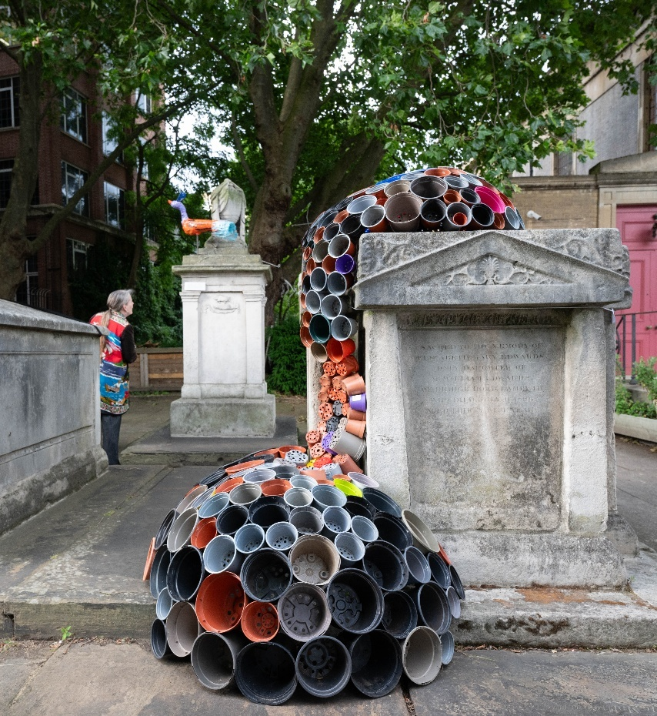
Creative Projects: our new exhibition and event spaces, the main nave’s excellently improved acoustics and embedded accessibility are enabling us to expand our cultural programme through diverse programming, new partnerships and an increased focus on co-creation. Since reopening, we have hosted exhibitions by artists facing repression, others with experiences of homelessness as well local creatives alongside world-class musicians from the London Philharmonic Orchestra and Southbank Sinfonia. We produce the annual arts, heritage and community Waterloo Festival and develop large-scale projects such as the Historic England funded The Lost City of Cardboard and Arts Council funded Utopia: A New World for Everyone. Our weekly art class, monthly creative writing activities and storytelling workshops, as well as regular events by our culture club are encouraging increased access to concerts, theatre productions and exhibitions to those who never felt creative engaged before.

Churchyard Garden: a place of sanctuary for many, including those with support needs. Our award-winning historic churchyard garden in the heart of Waterloo is cared for by a team of volunteers. Anyone can join the regular team, learn new skills and engage with a strong community of garden friends. Our dedicated team are honoured to have won Gold awards for their work and the garden has been named Churchyard of the Year by London in Bloom.

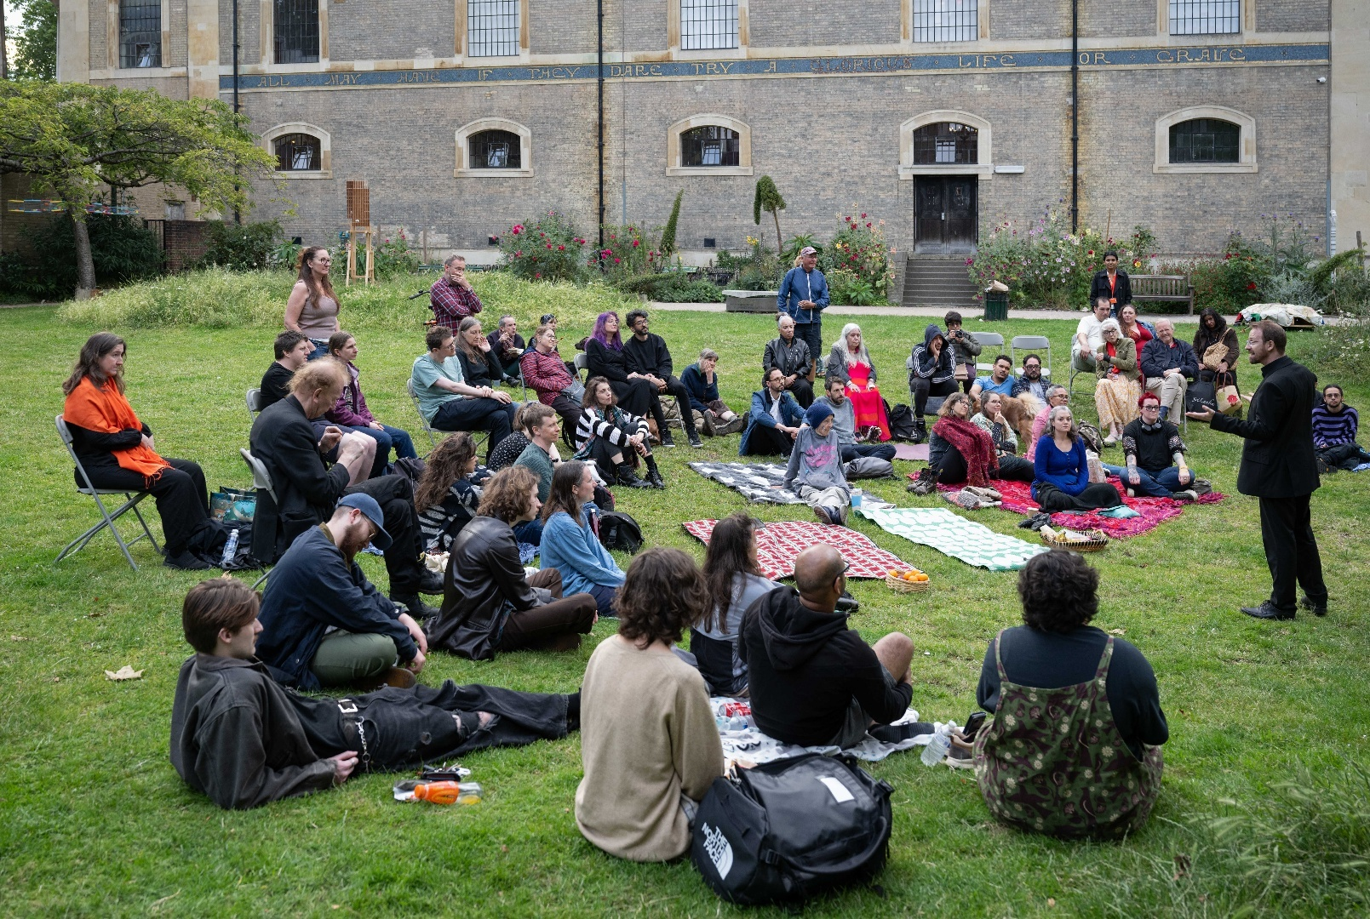

OUR IMPACT
2050+ participants and 170+ volunteers across TBAW activities in 2024

“He really struggles with social anxiety, and so I wasn’t even sure that he would turn up. However, as soon as he came in the door he mentioned it, so it has made a huge difference to his outlook which is great.” – Participant’s guardian

“I feel part of a community and it gives you confidence.” – Participant

“You have a real sense of community, and the privilege of being alongside a diverse group of other volunteers…” – Participant

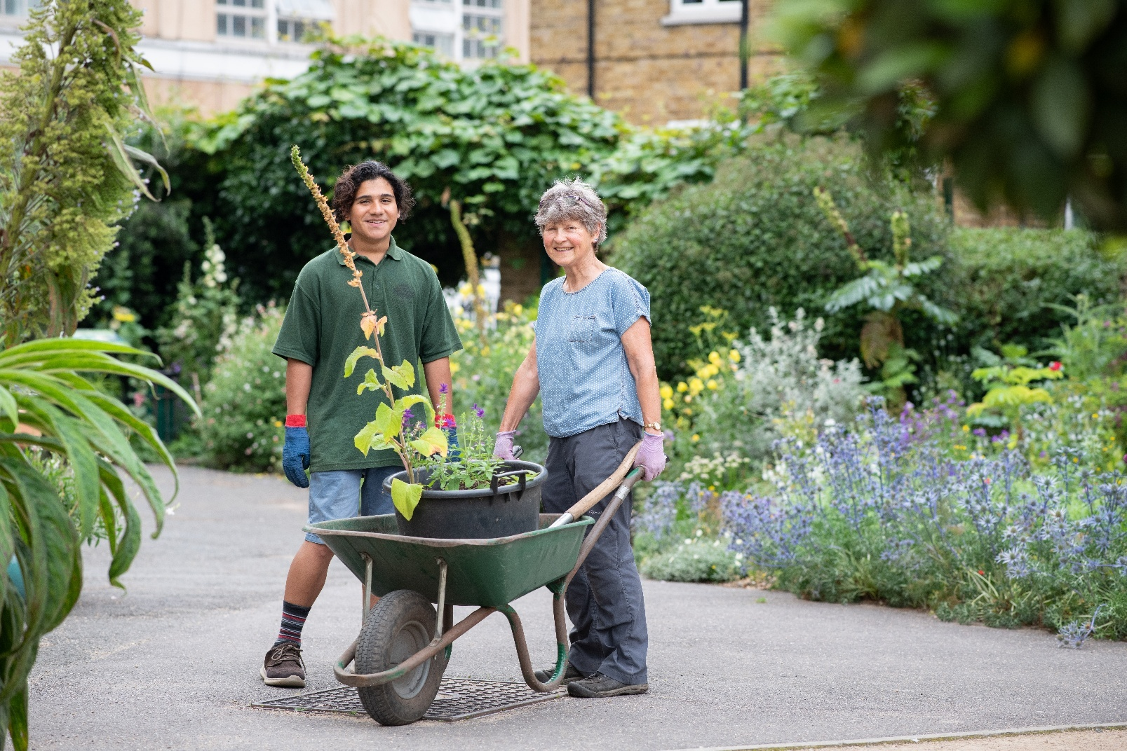

MAIN PURPOSE AND OVERVIEW OF ROLE
We are constantly on the lookout for candidates who can help our charity and staff to achieve the goals and objectives of TBAW. The recent transformation of our base into an accessible community and arts space has helped us to increase our focus on project delivery including weekly and one-off creative programmes. We are particularly keen to bring to our Board those who have experience in the arts, culture, venue and/or community sector to compliment the work, skills and interests of the other trustees and our vision for the coming years.

RESPONSIBILITIES
Our trustees must act in the interests of the charity at all times. As a member of the Board each trustee is required to carry out the duties and responsibilities of a trustee as defined in the Articles and Law and act in accordance with the Trustees Code of Conduct, Nolan Principles, policies, procedures and operational structure approved by the Board. The Board has collective responsibility to ensure that the purpose of the Board is fulfilled and each trustee is personally accountable.

The purpose of the Board is defined in the Operational Structure as follows:

- To provide strategic direction to TBAW through the adoption of Board policies and plans

- To be responsible for all matters relating to the running of TBAW including
  - The approval, monitoring and continual development of a long term plans with measurable objectives and milestones
  - The approval and management of an annual Budget
  - The fundraising for TBAW
  - The appointment of a Chief Executive, and the ongoing terms and conditions of employment of the Chief Executive
  - The employment of other TBAW staff

- To set up and appoint members to sub-groups and committees, and to delegate to the sub-groups, committees and the Chief Executive in order to optimise the effectiveness of TBAW.

Each trustee is expected to:
- Ensure that TBAW successfully brings our vision to life, delivering our objectives in accordance with the Articles and our business plans

- Champion TBAW by personally, or through others, engaging with current and potential partners, funders and other stakeholders or advisors

- Keep well informed about the strategic context for our work at TBAW, actively seeking out opportunities, identifying risks and overcoming obstacles

- Work with other trustees ensure that appropriate policies, procedures, activities and resources are in place to:
  - Provide sound governance, internally and externally
  - Ensure that TBAW remains solvent and credible
  - Steward resources to long term benefit

- Work with other trustees to maintain an appropriate mix of skills and perspectives on the Board and in committees, sub-groups or advisory panels, and take a full part in the evaluation of and appropriate training for all board members

QUALITIES, EXPERIENCE AND TIME REQUIRED
Trustees should have most or all of the following attributes:
- Ability to review as a critical friend
- Act as a team player
- Ability to delegate
- Strategic thinker
- Good communicator
- Passion for social justice, diversity and inclusion
- Active interest and network of contacts and resources in the Waterloo area of London, the London boroughs of Lambeth and Southwark or the groups for whom we seek to work more widely
- Capacity and commitment to offer sufficient time to the Board and any sub groups (a minimum of monthly board meetings plus 2 half-away-days a year and preparation or follow up)
- Willingness to shoulder wider responsibility as a trustee, as identified in the role specification
- Willingness to work with a C of E parish as St John’s is our foundation partner
- Specific skills and experience to balance the Board as a whole

The Board should include members with a mix of the following skills and experience:
- Heritage and/or Arts – locally and/or nationally
- Local community organisations
- Supporting people in the community, those facing advantages as well as isolation and/or homelessness
- Marketing, Communications and PR
- Fundraising / Finance and risk management
- Governance and Legal
- Strategic management
- Employment law and practice

APPLY FOR THE ROLE
If this role is of interest to you, kindly reach out to Canon Giles Goddard (giles@stjohnswaterloo.org) for an initial chat. Following that, potential applicants are asked to submit a CV which will be reviewed by the Board against the skills needed and the range of perspectives covered in the Board and associated committees.

Chosen applicants will be then invited for an interview by at least two Board members. On the basis of these processes, a new candidate will then be appointed directly by the or by an ordinary resolution of the members as defined in the Articles.

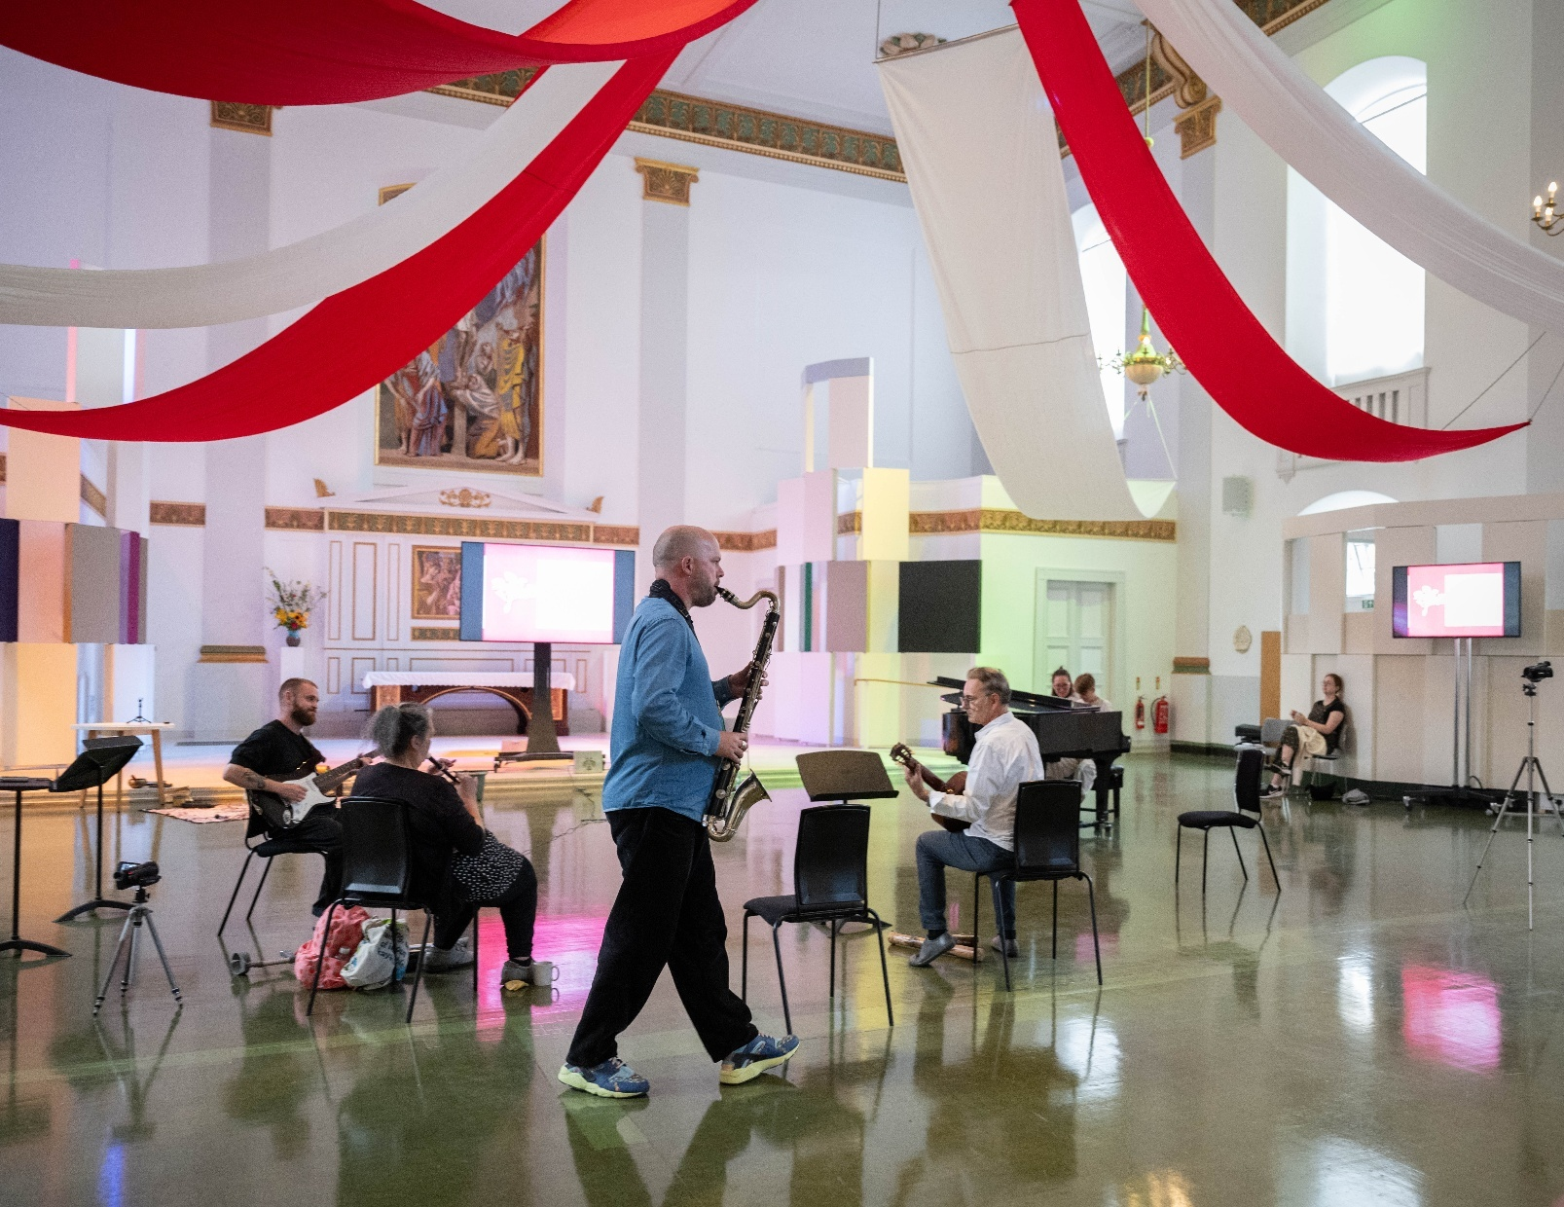
Pictures by Eleanor Bentall (for St John’s Waterloo and Waterloo Festival)

